**Online Exam Portal Project**

**Team members:**

1) Kang Cheng Phang

2) Priscilla Low

3) Andrew THS

4) Jony Liu

5) Cheong Si Sien

**Business Requirements Document**

* A summary statement.
* Project objectives.
* Needs statement.
* Project scope and limitation.
* Customer Service.
* Business Model

**Summary:**

With the continuous updating of educational ideas and the continuous development of information technology, the traditional examination methods have been unable to meet the needs of course providers and students. The online examination system emerges to address this demand gap and with the current COVID pandemic, the rush for this demand has been accelerated. Online examination system helps to save a lot of manpower, material resources and also improves the flexibility of the examination. With an online marketplace platform for test makers and examinees, our business role is to facilitate this market demand and innovate in this education arena. As a part of the innovation in meeting the needs of the examinees and educators, the online examination system is becoming popular. The online examination system breaks the limitation of the traditional paper and pen method and will be well received by many teachers and examinees.

Online examination has many advantages, such as convenience and flexibility. It is easy to manage and maintain with the current advancement in software development and hardware tools. The integration of Information technology in education and teaching is in line with the inevitable trend of education innovation.

**Project objectives:**

This project is aimed at developing an online examination system for students and course providers. The purpose of the system is to completely automate the old and manual procedure of conducting examination and assessment with a new computerized online system.

The system will allow students to register and take the exam online instead of using paper and pen. The online system provides several functions for the different set of users (administrators, quizmasters and students). Users will have to register before using the system thus enhancing security.

The system allows quizmasters to upload questions and answers online. The system will mark and grade the students from the answers provided by the Quizmasters. Communication links by email and telephone call are set up for the students to liaise official matters with the service provider. Administrators will be able to use the system for administrative tasks involving the quizmasters and the students.

**Needs statement:**

The traditional pen and paper method for taking examinations has many drawbacks such as time consuming, difficulty of analysing the test results manually. In addition, invigilators are required to supervise examination venues during the examinations. Results are not accurate since marking, grading and score tabulations are done manually and prone to human errors. The chance of losing examination scripts is higher in the manual systems and there may be a lack of security involving the examination scripts and around the examination venues.

Checking of results is also time consuming since it is done manually. There is a limitation to the number of students who can take the examination at any one given time due to the possible space constraint and the lack of suitable venues.

With the advancement of information technology, an online examination system is now a feasible solution to replace the traditional paper and pen method. The online system will help to overcome the existing problems in the manual system. Online examination system provides increased security as the information is stored in secured databases with built-in security features to reduce human errors. It also helps to reduce time wastage and improve productivity drastically. Student performance tracking can be summarized in charts and displayed on the student dashboard to give them an updated overview of their progress. The student dashboard will guide the students to take greater ownership of their progress and drive themselves to set greater heights for achievements in their studies.

**Project scope and limitation:**

This online examination system will be developed for a commercial training provider to conduct examinations of their students online on a “paid per exam“ basis.

**a)** Multiple students can take the same exam at the same time.

**b)** Results will be processed and score/grades will be tabulated automatically and displayed to the students.

Quizmasters can view and amend answers to the questions/ student’s score/grades if needed.

**c)** The types of questions are classified into 7 categories.

i) True or False ii) Fill in the blank. iii) Multiple Answers. iv) Ordering.

v) Multiple Choice vi) Matching, and vii) Numeric [Margin of Error and Range of Values]

**d)** Each examination can be set by only one Quizmaster. A Quizmaster can set more than one

Examination.

**e)** Administrators have the authorization to all the functions available to the Quizmasters.

**f)** An examination can be published by selecting a topic, setting the target score, timers, choosing the number of questions. Only the Quizmaster can set the exams.

**g)** Topics are classified according to multiple categories. There are three levels of difficulty: Basic,

intermediate, Advanced.

**h)** A rewards online program for Quizmasters. Moderators can do a quality check on the questions created/added into the question bank by the Quizmasters.

**i)** For registered students under trial account, a free sample test of up to 5 questions for every specific category is made available to students before deciding to pay for an examination or to get a paid membership. Students who are on paid membership can choose to take any set of examination, customised based on categories (subject to their subscription) and difficulty level of their preference.

**j)** Feedback survey system available for students/exam takers after an exam.

**Roles and Responsibilities:**

**Students:** paying customers to the service provider to enrol into the online examination system by subscribing to a 3-tier membership program.

**Membership tiers:**

* Trial Session (free access to up to 5 sample questions for each category)
* Silver (6 months and choice of 2 categories) + recorded video of tutorial
* Gold (6 months and choice of 3 categories) + recorded video of tutorial + 1 free category + exclusive content
* Platinum (1 year all categories) + live tutorial + 3 + exclusive content

**Business Model**: Subscription-based (3 months/6 months/1 year) + Bundle discounted pricing (3 pax per bundle).

**Additional features for members:** Members who are able to complete and pass a certain number + difficulty level of the online examination will unlock achievement/badges. This will be shown on their profile page.

Members will also receive a digital certification. This certification (accessible via an url link) can be posted on their LinkedIn or other social media accounts.

Members (Gold tier and above) will be entitled to access exclusive content ranging from micro-level such as lesson tutorials to wider scale such as the relevant industry’s market outlook.

For example, if a member has expressed interest in computing science or as a software developer during registration and has partake relevant examinations in the corresponding category, he/she will also be updated on the latest trend or news on the tech industry.

The examination questions will be reviewed on a monthly basis by a group of QuizMasters to ensure that the questions satisfy the following criterias - Difficulty Level, Usability, Relevance and Assessment of knowledge. Feedbacks from students will provide a good gauge and the QuizMasters will then re-evaluate and publish updated online examinations.

**Feedback:** At the end of the online examination, Members (Students) will be directed to a feedback page to rate the exam based on the following parameters, at a scale of 1 to 5.

* Difficulty Level
* Usability
* Relevance
* Assessment of knowledge
* Additional feedback/comments (free-text, if any)

**Quizmasters:** Subject matter experts(Teachers) can apply to be Quizmasters to provide test questions to the commercial training provider for the online examination. An Interview will be set up to finalise the appointment of the Quizmaster in person and conduct due diligence on the qualifications and experience of the Quizmaster. Upon confirmation of appointment as Quizmaster, Quizmaster will be paid a retainer fee to provide test questions to the online examination system on a yearly basis.

Every week, the Quizmasters will be tasked to add more questions and update/change the value of the question/answer bank to avoid members (students) to record the answers and distribute amongst themselves.

**QuizMaster Rewards:** Quizmaster will generate and maintain exam questions and answers for each category (topic) using UI. For each question (with answers) that the moderators add into the question bank, they will be rewarded with 1 point. Feedback from students can also contribute to the point system.

Positive feedback from members will earn 1 additional point whereas numerous and consecutive negative feedback will lead to a performance re-assessment of the Quizmaster with the management. Subsequent negative feedback will lead to a limit placed on the Quizmaster’s reward system.

Rewards come in different tiers based on the points accumulated.

Rewards redemption: add and subtract points.

In the event the Quizmaster wishes to leave the company, the Administrators are tasked to check the Quizmaster’s outstanding reward points and disburse the reward accordingly before closing the account.

**Moderators:**

Moderators: Employed by the commercial training provider to do quality assurance on the Quizmasters’ submission and approved the questions to be admitted to the question bank.

**Customer Service:**

Service assurance: Online examination system to be available 24hours per day, 365 days per year except on the first Sunday of each month from 12AM to 7AM for system maintenance.

Email Support: We provide a 4hrs response time from 10am to 6pm, Monday to Sunday. Remote access software will be installed on the customer’s computer and would allow our software engineer to troubleshoot their technical problems.

Telephone Support: Telephone enquiries from 10am to 6pm, Monday to Friday except Public Holidays. After office hours, we provide email support.

Subscription refund: Refunds will be reimbursed upon request and verification basis. It will be computed on monthly basis and pro rated to the month of the request. Refunds will be credited back to the credit card account tendered during the payment session. No cash refunds will be entertained.

**Package Matrix:**

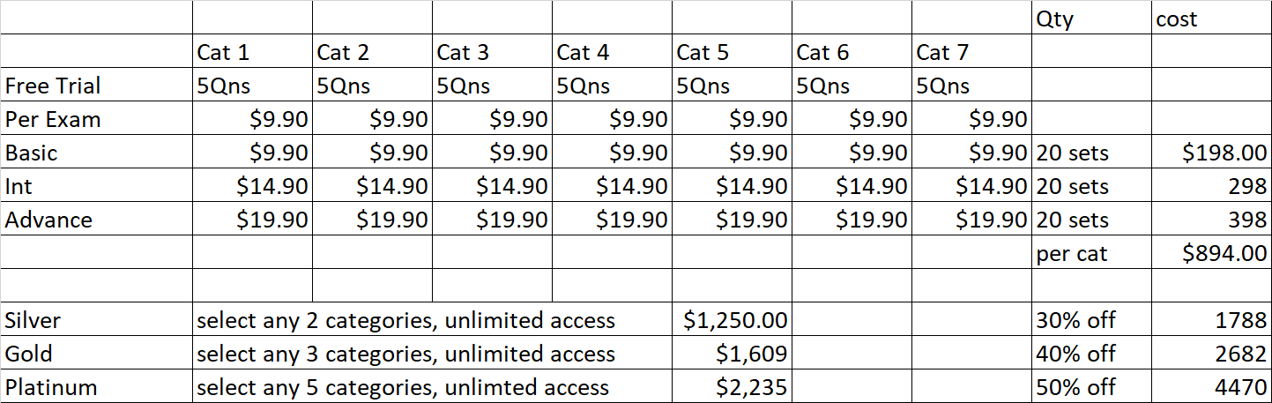

*\*Package based on 6 mths contract for Silver, Gold and Platinum. Additional 5% will be given for 12 months contract for each category.*

**User Role Definition:**

|  |  |  |
| --- | --- | --- |
| **Administrator** | **Moderator(Teacher)** | **Student** |
| Add new user (Mod/Student) | Manage Student Scores  (Max, min, average, mean score) | Registration. (Self-add new user) |
| Edit existing user (Mod/Student) | Create exam/ID-Date/time & Venue [Session] | Log in for the trial session to attempt sample questions (5 questions) of different categories. |
| Create exam/ID-Date/time & Venue [Session/Course] | Generate and maintain exam questions and answers for each category using UI. Questions and answers will be stored in database | OR Log in for the complete session if payment is verified.  [Students can skip the trial session and opt for the complete session, so there will be 2 options for them to choose. Trial or Complete] |
| Can update user details, reset Mod/Student password | Maintain(grade/edit) Students’ scores. | Select the choices  OR  type in the input fields for each exam question |
| Delete Mod/Student | Redeem rewards - 1 question 1 point. | Feedback mechanism after completion of exam |
| Can grant access for Student to enter the session  [Condition: Students must make payment in order to be granted access to complete session.] |  |  |

**Functional Requirements**

Flow Diagram

Login process - All users

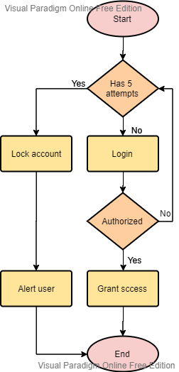

Payment Process - Student

Note: if payment is Boolean, then it will be changed from ‘false’ to ‘true’ instead of ‘0’ to ‘1’.

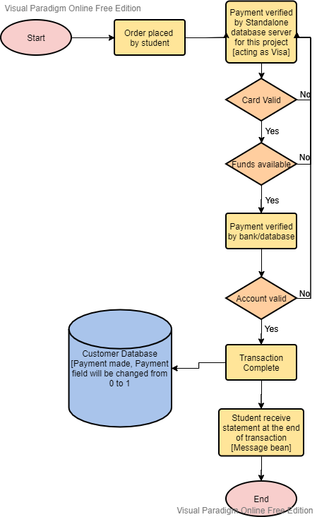

**CRUD Operation - Administrator**

**[Create and edit user] - See next page for deletion**

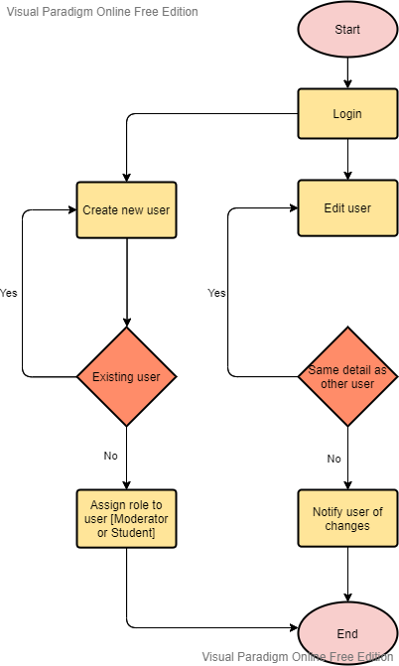

**CRUD Operation - Administrator**

**[delete user]**

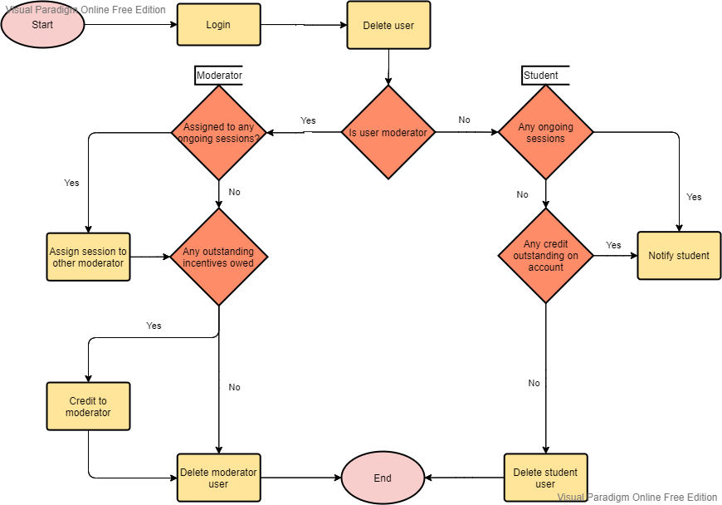

**Creating exam - Moderator (Administrator can assign themselves as Moderator if they hold dual appointment)**

**Database Design**

|  |  |  |  |
| --- | --- | --- | --- |
| **STUDENT** | | | |
| Data | Datatype | Constraint | Nullable |
| STUDENT_ID | INT, GENERATED BY DEFAULT ON NULL AS IDENTITY | Primary Key | Not Null |
| STUDENT_NAME | VARCHAR2(50) |  | Not Null |
| STUDENT_EMAIL | VARCHAR2(50) |  | Not Null |
| STUDENT_CONTACT | VARCHAR2(20) |  | Not Null |
| STUDENT_USERNAME | VARCHAR2(50) |  | Not Null |
| STUDENT_PASSWORD | VARCHAR2(50) |  | Not Null |
| ACCOUNT_TYPE | INT, 1 to 4 for each membership tiers respectively, i.e. 1 for Trial account, 2 for Silver, 3 for Gold, 4 for Platinum. |  | Not Null |

|  |  |  |  |
| --- | --- | --- | --- |
| **PAYMENTS** | | | |
| Data | Datatype | Constraint | Nullable |
| PAYMENT_ID | INT, GENERATED BY DEFAULT ON NULL AS IDENTITY | Primary Key | Not Null |
| PAYMENT_MODE | VARCHAR2(40) |  | Not Null |
| PAYMENT_AMT | DOUBLE |  | Not Null |
| STUDENT_ID | INT | Foreign Key to STUDENT table. | Not Null |
| CATEGORY_ID | INT | Foreign Key to CATEGORY table. | Not Null |
| MEMBERSHIP_ID | INT | Foreign Key to MEMBERSHIP table. | Not Null |

|  |  |  |  |
| --- | --- | --- | --- |
| **MEMBERSHIP** | | | |
| Data | Datatype | Constraint | Nullable |
| MEMBERSHIP_ID | INT, GENERATED BY DEFAULT ON NULL AS IDENTITY | Primary Key | Not Null |
| SUB_STARTDATE | DATETIME |  | Not Null |
| SUB_ENDDATE | DATETIME |  | Not Null |
| STUDENT_ID | INT | Foreign Key to STUDENT table. | Not Null |

|  |  |  |  |
| --- | --- | --- | --- |
| **QUIZMASTER** | | | |
| Data | Datatype | Constraint | Nullable |
| QM_ID | INT, GENERATED BY DEFAULT ON NULL AS IDENTITY | Primary Key | Not Null |
| QM_NAME | VARCHAR2(50) |  | Not Null |
| QM_EMAIL | VARCHAR2(50) |  | Not Null |
| QM_CONTACT | VARCHAR2(20) |  | Not Null |
| QM_USERNAME | VARCHAR2(50) |  | Not Null |
| QM_PASSWORD | VARCHAR2(50) |  | Not Null |
| SALARY | INT |  | Not Null |

|  |  |  |  |
| --- | --- | --- | --- |
| **QUIZMASTER_EXAM** | | | |
| Data | Datatype | Constraint | Nullable |
| QM_ID | INT | Primary Key | Not Null |
| EXAM_ID | INT | Foreign Key to EXAMS table. |  |

|  |  |  |  |
| --- | --- | --- | --- |
| **QUIZMASTER_REWARDS** | | | |
| Data | Datatype | Constraint | Nullable |
| QM_ID | INT | Primary Key | Not Null |
| REWARDS_ID | INT | Foreign Key to REWARDS table. |  |

|  |  |  |  |
| --- | --- | --- | --- |
| **MODERATOR** | | | |
| Data | Datatype | Constraint | Nullable |
| MOD_ID | INT, GENERATED BY DEFAULT ON NULL AS IDENTITY | Primary Key | Not Null |
| MOD_NAME | VARCHAR2(50) |  | Not Null |
| MOD_EMAIL | VARCHAR2(50) |  | Not Null |
| MOD_CONTACT | VARCHAR2(20) |  | Not Null |
| MOD_USERNAME | VARCHAR2(50) |  | Not Null |
| MOD_PASSWORD | VARCHAR2(50) |  | Not Null |

|  |  |  |  |
| --- | --- | --- | --- |
| **EXAMS** | | | |
| Data | Datatype | Constraint | Nullable |
| EXAM_ID | INT, GENERATED BY DEFAULT ON NULL AS IDENTITY | Primary Key | Not Null |
| CATEGORY_ID | INT | Foreign Key to CATEGORY table. | Not Null |
| QNBANK_ID | INT | Foreign Key to QNBANK table. | Not Null |

|  |  |  |  |
| --- | --- | --- | --- |
| **QNBANK** | | | |
| Data | Datatype | Constraint | Nullable |
| QNBANK_ID | INT, GENERATED BY DEFAULT ON NULL AS IDENTITY | Primary Key | Not Null |
| QM_ID | INT | Foreign Key to QUIZMASTER table. | Not Null |

|  |  |  |  |
| --- | --- | --- | --- |
| **QUESTIONS** | | | |
| Data | Datatype | Constraint | Nullable |
| QN_ID | INT, GENERATED BY DEFAULT ON NULL AS IDENTITY | Primary Key | Not Null |
| QN_CONTENT | VARCHAR2(2000) |  |  |
| QNBANK_ID | INT | Foreign Key to QNBANK table. | Not Null |
| QM_ID | INT | Foreign Key to QUIZMASTER table. | Not Null |

|  |  |  |  |
| --- | --- | --- | --- |
| **ANSWERS** | | | |
| Data | Datatype | Constraint | Nullable |
| ANS_CONTENT | VARCHAR2(2000) |  |  |
| QN_ID | INT | Foreign Key to QUESTIONS table. | Not Null |

|  |  |  |  |
| --- | --- | --- | --- |
| **CATEGORY** | | | |
| Data | Datatype | Constraint | Nullable |
| CATEGORY_ID | INT, GENERATED BY DEFAULT ON NULL AS IDENTITY | Primary Key | Not Null |
| CATEGORY_NAME | VARCHAR2(50) |  | Not Null |
| DIFFICULTY_ID | INT | Foreign Key to DIFFICULTY table. | Not Null |

|  |  |  |  |
| --- | --- | --- | --- |
| **DIFFICULTY** | | | |
| Data | Datatype | Constraint | Nullable |
| DIFFICULTY_ID | INT, GENERATED BY DEFAULT ON NULL AS IDENTITY | Primary Key | Not Null |
| DIFFICULTY_TYPE | VARCHAR2(50) |  | Not Null |

|  |  |  |  |
| --- | --- | --- | --- |
| **ADMIN** | | | |
| Data | Datatype | Constraint | Nullable |
| ADMIN_ID | INT, GENERATED BY DEFAULT ON NULL AS IDENTITY | Primary Key | Not Null |
| ADMIN_NAME | VARCHAR2(50) |  | Not Null |
| ADMIN_EMAIL | VARCHAR2(50) |  | Not Null |
| ADMIN_CONTACT | VARCHAR2(20) |  | Not Null |
| ADMIN_USERNAME | VARCHAR2(50) |  | Not Null |
| ADMIN_PASSWORD | VARCHAR2(50) |  | Not Null |
| SALARY | INT |  | Not Null |

|  |  |  |  |
| --- | --- | --- | --- |
| **STUDENT_EXAM** | | | |
| Data | Datatype | Constraint | Nullable |
| STUDENT_ID | INT | Primary Key | Not Null |
| EXAM_ID | INT | Foreign Key to EXAMS table. |  |
| GRADES_ID | INT | Foreign Key to GRADES table. |  |
| FEEDBACK_ID | INT | Foreign Key to FEEDBACK table. |  |

|  |  |  |  |
| --- | --- | --- | --- |
| **FEEDBACK** | | | |
| Data | Datatype | Constraint | Nullable |
| FEEDBACK_ID | INT, GENERATED BY DEFAULT ON NULL AS IDENTITY | Primary Key | Not Null |
| FEEDBACK_DIFFICULTY | INT (min 1, max 5) |  | Not Null |
| FEEDBACK_USABILITY | INT (min 1, max 5) |  | Not Null |
| FEEDBACK_RELEVANCE | INT (min 1, max 5) |  | Not Null |
| FEEDBACK_ASSESSKNOW | INT (min 1, max 5) |  | Not Null |
| FEEDBACK_CONTENT | VARCHAR2(500) |  |  |

|  |  |  |  |
| --- | --- | --- | --- |
| **GRADES** | | | |
| Data | Datatype | Constraint | Nullable |
| GRADES_ID | INT, GENERATED BY DEFAULT ON NULL AS IDENTITY | Primary Key | Not Null |
| GRADE_TYPE | CHAR(1) |  |  |
| GRADE_SCORE | FLOAT |  | Not Null |

|  |  |  |  |
| --- | --- | --- | --- |
| **REWARDS** | | | |
| Data | Datatype | Constraint | Nullable |
| REWARD_ID | INT, GENERATED BY DEFAULT ON NULL AS IDENTITY | Primary Key | Not Null |
| REWARD_POINTS | INT |  | Not Null |
| REWARD_TIER | INT |  |  |
| REWARD_TYPE | VARCHAR2(500) |  |  |
| REWARD_STATUS | BOOLEAN, 1 for reward claimed, 0 for reward not claimed. |  | Not Null |

**ER DIAGRAM:**

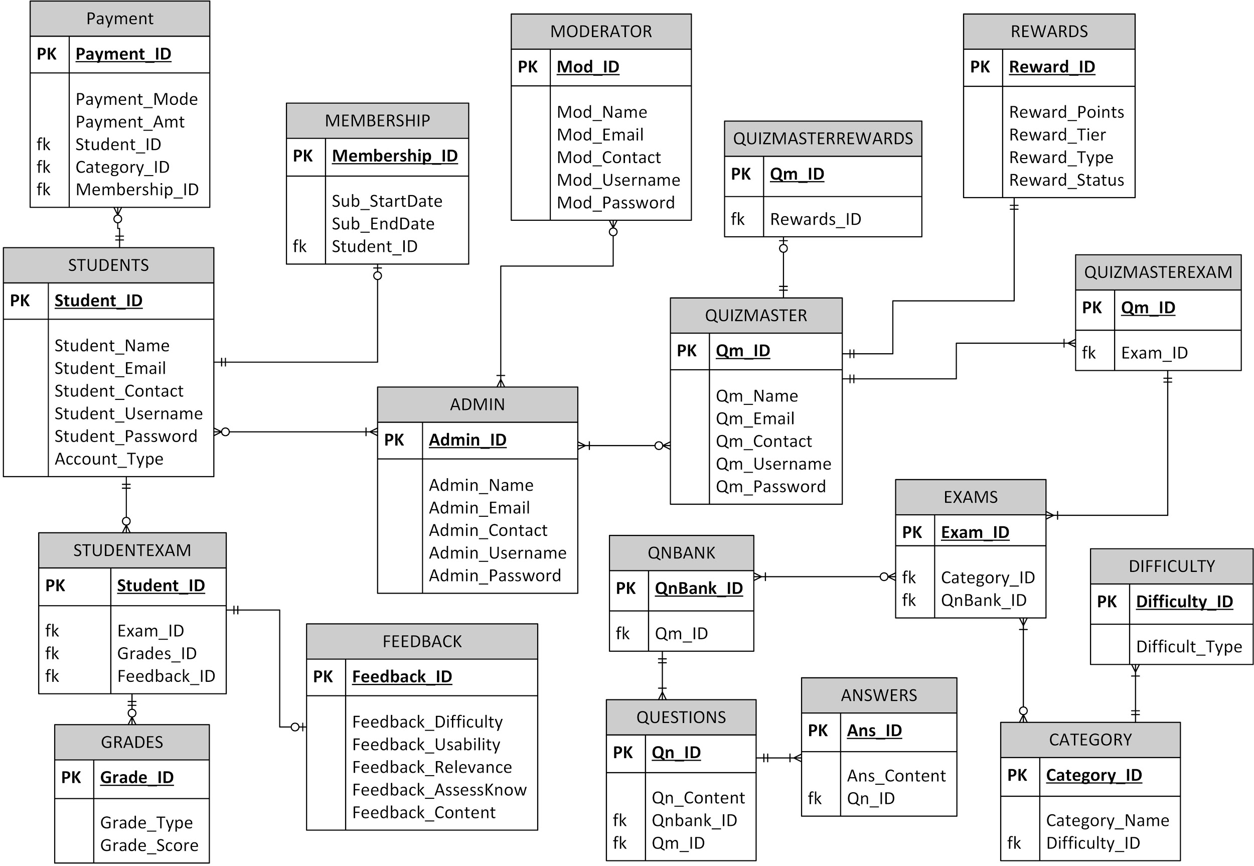

Note:

1. A student can make no payment(not taking exam) or make many payments(different exams). A payment is made by one student only(cannot have 2 students paying for the same payment invoice).

2) A student can have zero grades(never take exam) but an exam result belongs to only one student.

3) A Quiz Master can set zero or more exams but one exam can only be set by only one moderator.

Eg:Java exam set by Chandra only and not by Chandra and Simon. But Chandra can set more than

one exam, eg: Java SE and Java EE exams

4) An exam can select from one or more Question banks and every Question bank may be used by 1 or

more exams or not used at all.

5) A question bank can have many different questions, each question can have one or many answers.

6) Each exam may belong to different categories, like for example Business IT Exam belongs to IT and

Business Categories. Each category may be the topic for different exams.

7) A student may give a feedback for an exam upon completion or the student may not give any

feedback at all. A feedback belongs to one and only one exam taken by a student.

8) A student can have zero or more grades depending on the exams he/she takes. A grade is awarded

to one exam taken by one student only, the grades is not shared among a group of students aka no

project work assessment.

**USER INTERFACE:**



